# IT718 - Azure Lab

## Objectives

The purpose of this lab is to introduce you to basic services on the Azure.

## Prework

Sign up for your Azure account with your UNH email.

Try Azure for Students free today: <https://azure.microsoft.com/en-us/free/students/>

Get $100 credit and free developer tools. Sign up without a credit card. 12 months to use.

Training modules are located here: <https://docs.microsoft.com/en-us/learn/>

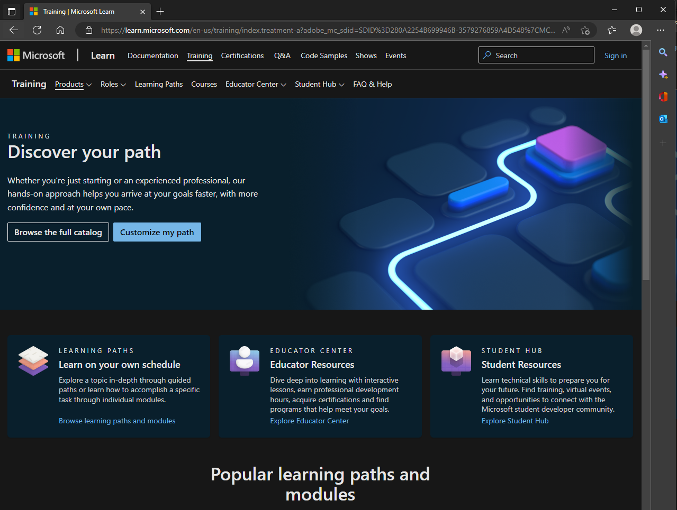

## Tasks

1. Core Cloud Services - Manage services with the Azure portal
2. Manage virtual machines with the Azure CLI
3. Create a Windows virtual machine in Azure
4. Create a Linux virtual machine in Azure
5. Host a web application with Azure App service
6. Create serverless logic with Azure Functions
7. Predict costs and optimize spending for Azure
8. Core Cloud Services - Introduction to Azure
9. Complete the My Dashboard -> "Create DevopsProject"
10. Show billing dashboard

Azure provides a lot of free self-guided training. Only a subset is included in this lab. If you have an interest in using Azure after this class you are encouraged to explore further. The Azure Fundamentals learning path is a good place to start: <https://docs.microsoft.com/en-us/learn/paths/azure-fundamentals/>

Lessons that create sandboxes will remove all resources when the sandbox expires. You should create a new sandbox for each lesson that requires one. Sandboxes are limited in permissions that are specific to that lesson.

Each task is worth 10 points. For tasks 1-7 to show your lab work you can either: 1) Capture the achievement popup when each module is completed. 2) Show all your badges on "Learn" "See all activity" page like below. Portal screenshots are needed for tasks 8, 9, & 10.

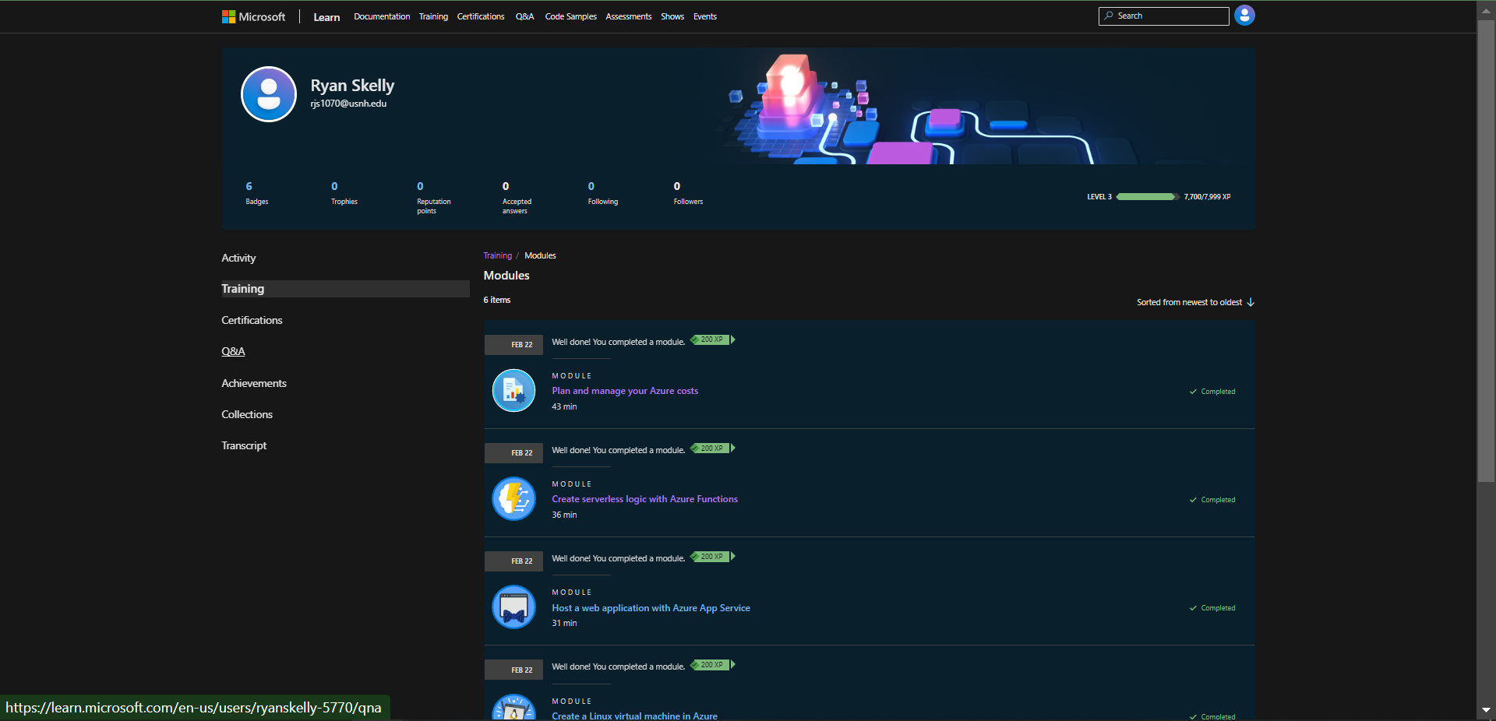

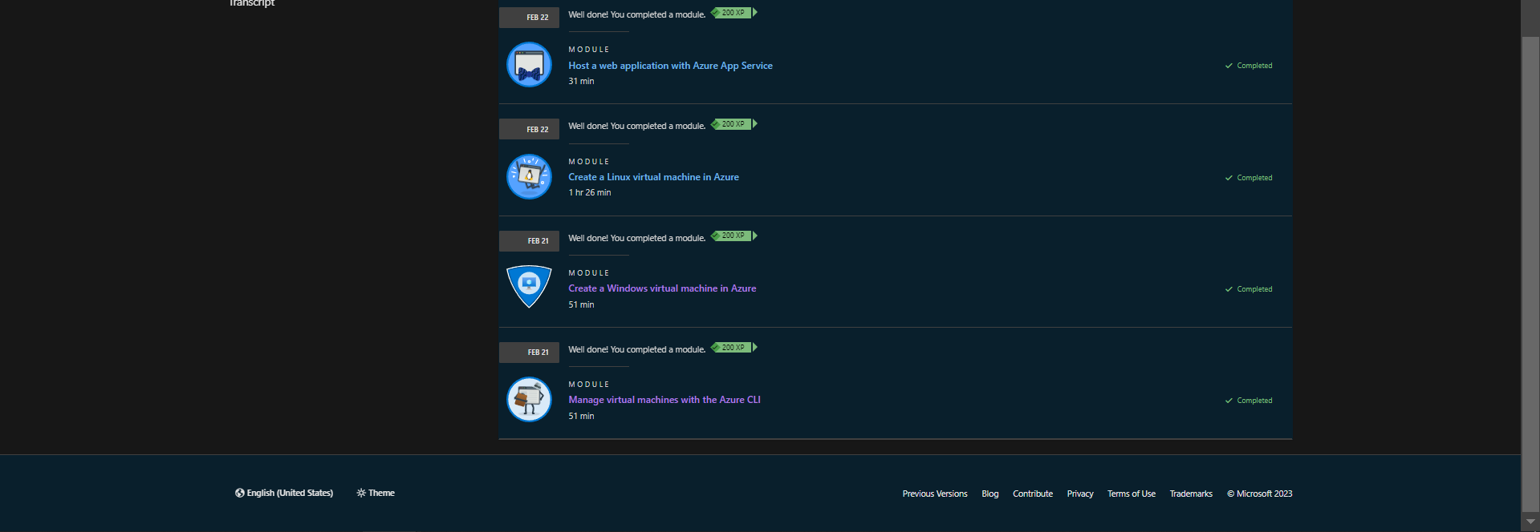

**Task 1: Choose the best tools for managing and configuring your Azure environment**

<https://docs.microsoft.com/en-us/learn/modules/management-fundamentals/>

**Task 2: Manage virtual machines with the Azure CLI**

<https://docs.microsoft.com/en-us/learn/modules/manage-virtual-machines-with-azure-cli/>

**Task 3: Create a Windows virtual machine in Azure**

<https://docs.microsoft.com/en-us/learn/modules/create-windows-virtual-machine-in-azure/>

**Task 4: Create a Linux virtual machine in Azure**

<https://docs.microsoft.com/en-us/learn/modules/create-linux-virtual-machine-in-azure/>

**Task 5: Host a web application with Azure App service**

<https://docs.microsoft.com/en-us/learn/modules/host-a-web-app-with-azure-app-service/>

Use the development language of your choice. The deployment might take a few minutes.

**Task 6: Create serverless logic with Azure Functions**

<https://docs.microsoft.com/en-us/learn/modules/create-serverless-logic-with-azure-functions/index>

The lesson follows the "classic function app" experience.

**Task 7: Plan and manage your Azure costs**

<https://docs.microsoft.com/en-us/learn/modules/plan-manage-azure-costs/>

**Task 8: Core Cloud Services - Introduction to Azure**

<https://docs.microsoft.com/en-us/learn/modules/manage-virtual-machines-with-azure-cli/>

*Lab report: (10 points) Replace this screenshot with your managed resource dashboard*

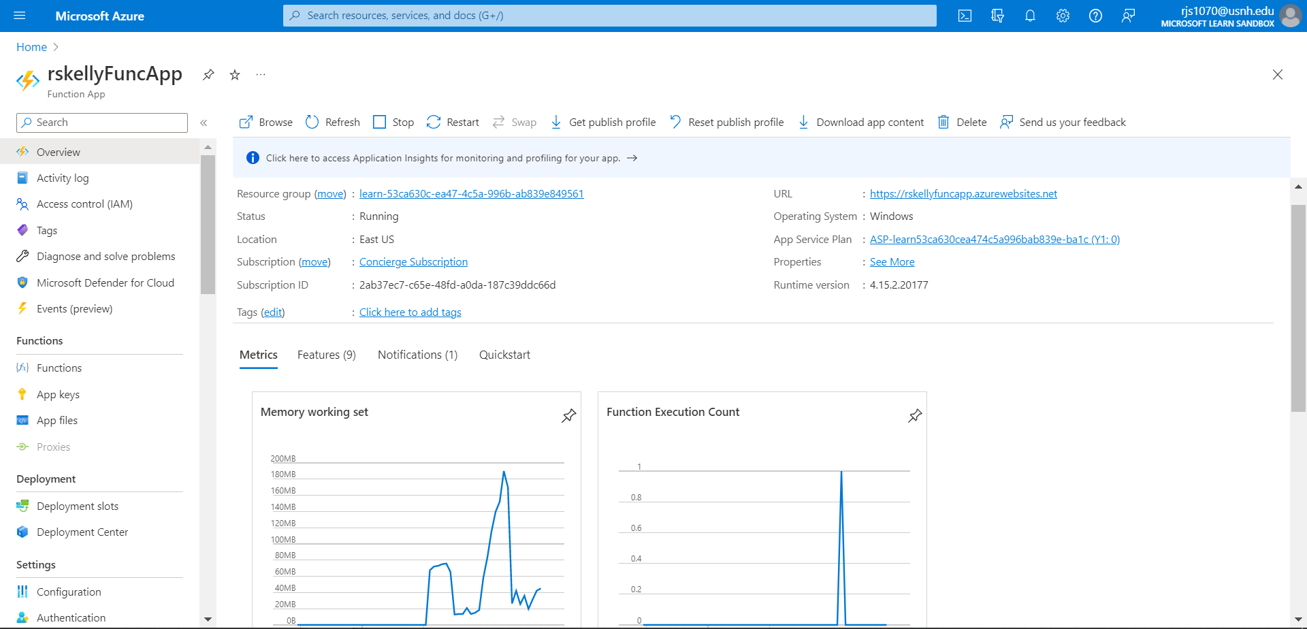

**Task 9: Show Advisor Page**

*Lab Report: (10 points) Replace this screenshot with your advisor dashboard*

<https://portal.azure.com/#blade/Microsoft_Azure_Expert/AdvisorMenuBlade/overview>

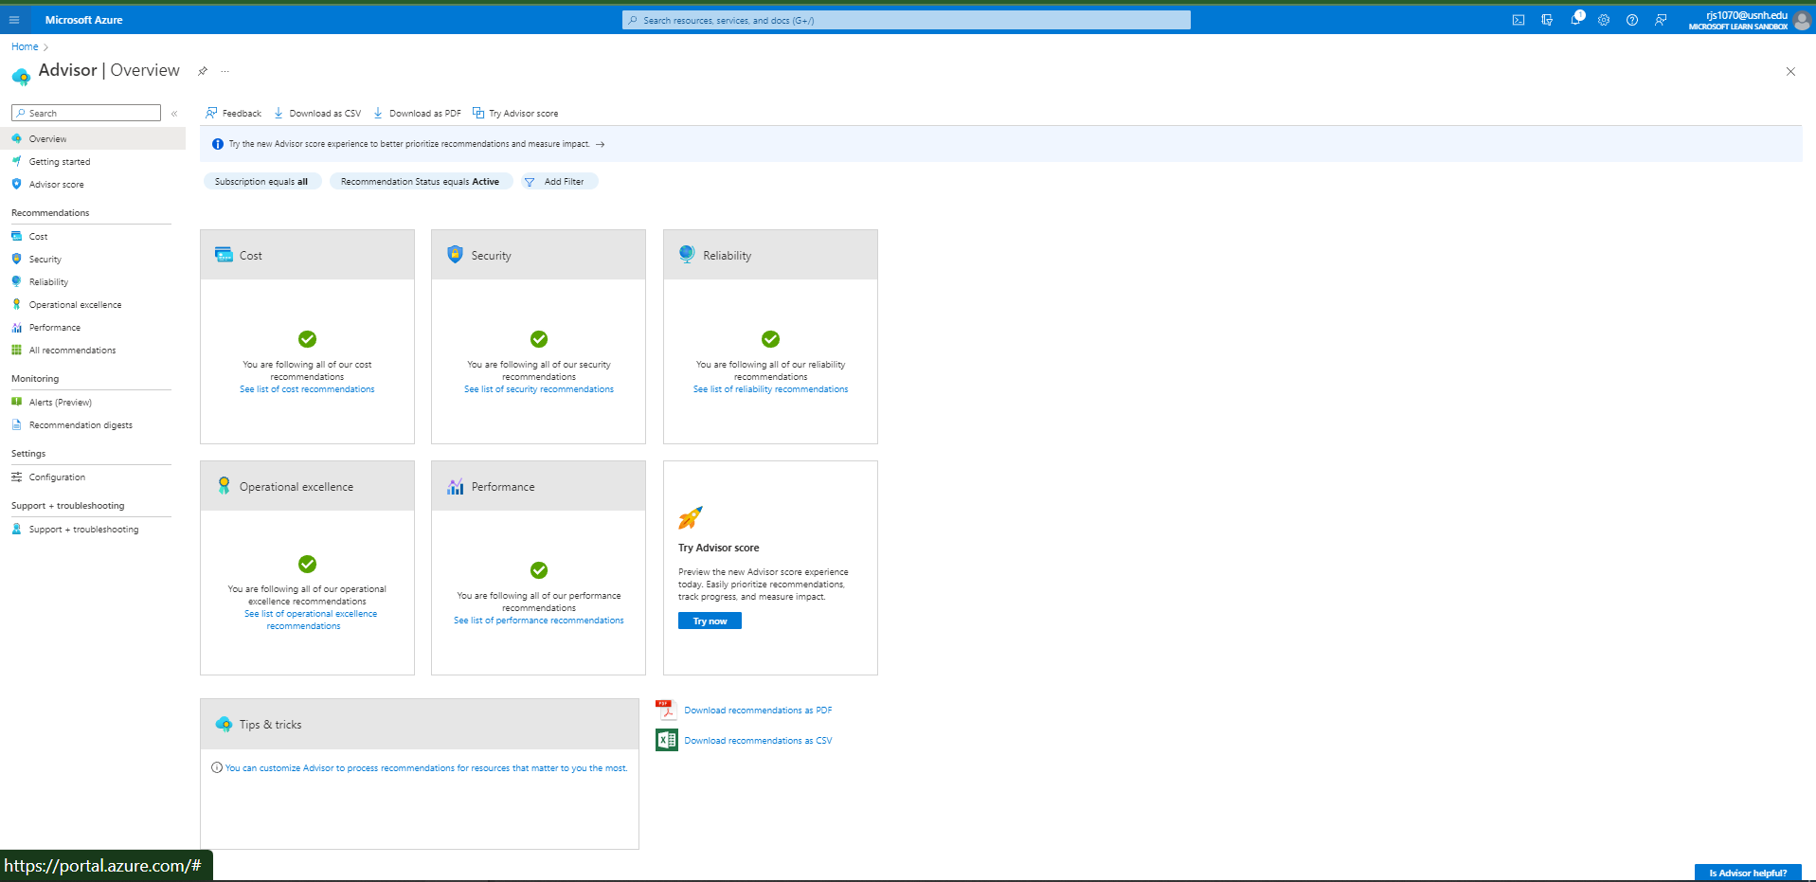

**Task 10: Show Billing Dashboard**

*Lab Report: (10 points) Replace this screenshot with your billing dashboard*

<https://portal.azure.com/#blade/Microsoft_Azure_GTM/ModernBillingMenuBlade/Overview>

Note: My spend will be different than yours as I spent time experimenting with services not part of this lab. Assuming you had no existing deployments, your on-going daily spend should be zero when you are done with this lab.